

**UNIVERSITY HIGHLANDS ELEMENTARY**

9388 Tower Road Burnaby BC V5A 4X6

Phone: 604-296-9036 Fax: 604-296-9078

http://universityhighlands.sd41.bc.ca/



**KINDERGARTEN**

**… WHERE THE**

**JOURNEY**

**BEGINS**

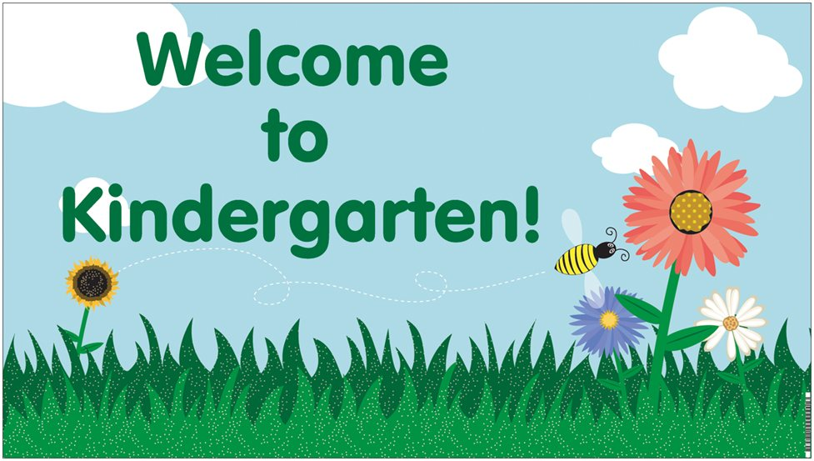

**Welcome to University Highlands Elementary School!** This is an exciting time for you and your child as you begin together the journey through your child’s school years. To assist your child in making a comfortable, gentle transition from home to school, we have arranged an Orientation Program for you and your child. (Please see the calendar for the Kindergarten phase-in schedule)

The school visit in September provides your child with an opportunity to explore their classroom environment and get to know their teacher and classmates. It also gives the teachers the opportunity to visit with you and your child prior to school starting.

We look forward to meeting you and your child. If you have any questions, comments, or concerns, please do not hesitate to call us at school or to have a discussion with us at our meeting.

See you in September!

At **University Highlands Elementary School**, we value our students and provide a stimulating and safe learning environment. The following are our school’s *central learning themes:*

**Sustainability:**

University Highlands Elementary School is the Ministry of Education’s first Leadership in Energy and Environmental Design (LEED) gold standard renovation site with design and technology to advance and support environmental sustainability. The school and grounds may be used to teach and practice sustainability and students will have the opportunity to become environmental stewards.

**Community involvement:**

The school will work in partnership with Burnaby’s Board of Education, Faculty at SFU, UniverCity Community Trust, Parks and Recreation and parents to create a rich and nurturing environment addressing diverse needs and global citizenship.

**Inquiry:**

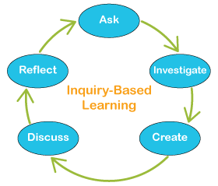Students and staff will be involved in learning opportunities that will explore and address real world problems. Inquiry-based learning supports children’s innate curiosity and sense of wonder. Students will be involved in learning opportunities that help them pose questions, investigate, solve problems, and draw conclusions about the world around them.

**Guiding Principles** that will help shape our practice at University Highlands Elementary include:

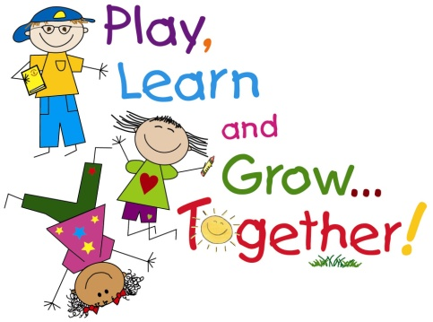

**Collaboration:**

*Meaningful and purposeful,*

* among students and staff
* between partner group
* with parents

**Conversation:**

*Dialogue to,*

* develop and use the skills and process of dialogue to deepen understanding and creatively solve important problems

**Contemplation:**

*Deep thinking over time,*

* through inquiry, students and staff will have opportunities to design and reflect upon their learning
* in consideration of big ideas and enduring understandings

**THE KINDERGARTEN PROGRAM**

The kindergarten program recognizes that each child is unique. Children learn at different rates and in different ways according to their abilities, interests and experiences. Our program emphasizes the development of the whole child. A variety of experiences are provided to foster the child’s social/emotional development, social responsibility, aesthetic and artistic development, intellectual development, and physical development. The teacher facilitates this growth by providing all children with a warm, caring and stimulating environment that encourages interaction, cooperation, exploration, and active, hands-on learning.

C:\Documents and Settings\antonia\Local Settings\Temporary Internet Files\Content.IE5\H5M3D4RN\MC900156745[1].wmfActivities in the primary classrooms are intentional, planned, child-centred, inclusive, and guided by the teacher. Our programs value diversity and emphasize learning through play. “In playing, children express, explore, combine, and extend what they have learned about sights, sounds, smells and textures of the world around them…children invent and explore by themselves and with other children, they bring together everything they have learned and are wondering about” (British Columbia Early Learning Framework, 2008, p. 12).

**HEALTH AND SCREENING PROGRAM**

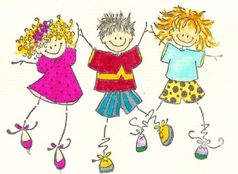Every child should have a physical examination before school begins. Your child will need to have a full series of vaccinations before entering kindergarten. A dental check is also recommended before September. If you have not already done so, please provide the office with your child’s complete record of immunizations.

During the school year, Kindergarten children will be checked by various health specialists. The community health nurse will do a vision, hearing and dental screening. The speech therapist will check for any speech irregularities if we feel there is a need. All these services are provided so that your child will have a successful start to school.

Please inform us of any concerns related to the health of your child (such as poor vision or hearing, allergies, speech difficulties, asthmas, heart conditions, etc.), so that we may support your child.

**ATTENDANCE**

In order for your child to gain a rich learning experience in kindergarten, it is important that he or she establish a habit of coming to school regularly and on time. If however, your child becomes sick, please keep him or her at home until he or she can fully participate in our daily activities. *If your child is going to be away from school or will be arriving late, please phone the office at 604-296-9036 and leave a message on the absence line, before 9:00 am. If your child arrives late (after 8:55am), you must check in at the office to obtain a late slip.*

**RECESS AND LUNCH**



Good nutrition is very important. A well-nourished child is a better learner. Children will need both a nutritious nut and peanut free snack and lunch to bring to school each day. As environmental stewardship is important to us, please pack lunches and snacks with reusable packaging so that we can keep our waste to a minimum.

**SUPPLIES**

Children will require:

* A backpack large enough for carrying a lunch, school notices, library books, artwork or any other “treasures” your child may make at school
* A pair of rubber soled running shoes (*velcro or slip-ons)* to be left at school. These are to be used as inside shoes and worn in the gym.
* An extra change of clothes in a cloth/gym bag to be left at school in case of spills or accidents.
* $20.00 to cover the cost of basic school supplies (or if preferred, please contact the classroom teacher directly for a supply list)

It is essential that your child be appropriately dressed for school. Comfortable, casual, washable play clothes are suitable and preferable for primary activities, as the children are often involved in many messy tasks using materials such as paint, glue, playdough, etc. As children also spend a portion of the day outside, please be sure to send your child to school with the appropriate clothing suited to the current weather conditions. Please refer to our “Westcoast Recess/Lunch” information attached.

Please label **all** coats, boots and other belongings with your child’s first and last name.

**C:\Documents and Settings\antonia\Local Settings\Temporary Internet Files\Content.IE5\A47FHCFN\MC900128384[1].wmfGETTING READY FOR KINDERGARTEN**

There are a number of ways you can support your child in his or her transition to kindergarten:

* Walk to school a few times, explore the school grounds and play at the playground.
* Encourage your child to play with friends in the neighbourhood.
* Talk to your child about the first week’s routine (please see the calendar for the kindergarten phase-in schedule)
* A week or two before school starts, begin to put your child to bed and wake him/her up at the times you will when school begins. Children of kindergarten age should be getting at least 10 hours sleep each night.
* To get ready for eating lunch at school independently, have little picnics this summer. Give your child time and encouragement to practice opening containers and juice boxes on his/her own. Practice hand washing and using the washroom independently.
* Help your child to learn their full name, address and telephone number.
* Encourage your child to print their name with a capital first and then small letters (e.g. **S h a r o n)**. Please note, it is not an expectation that your child will know how to print their name at the beginning of Kindergarten.
* Teach self-help skills, e.g., putting on and zipping up coats, fastening buttons, putting lids on containers, putting on own shoes, etc.

If your child experiences any anxiety during the first few days of school, reassure him/her that it takes time to adjust to a new situation. If your child experiences separation anxiety, take comfort in the fact that young children usually settle down quickly after you have left.

**PARENTS ARE WELCOME!**

Family connections are essential to children’s learning and development and are strongly encouraged in our primary programs. We value parent involvement and look forward to building positive home-school connections.

**Suggested Websites**



Burnaby Public Library has lots of great websites. Click on Kids’ page: [www.bpl.bc.ca](http://www.bpl.burnaby.bc.ca)

National Association of the Education of Young Children (for parents and teachers): [www.naeyc.org](http://www.naeyc.org)

An interactive reading site from alphabet to books:

[www.starfall.com/](http://www.starfall.com/)

Treehouse: [www.treehousetv.com](http://www.treehousetv.com)

Education Games in various subject areas: <http://www.abcya.com/kindergarten_computers.htm>

***☺ YOU ARE A TEACHER, TOO ☺***

***Children learn to talk by being spoken to. . .***

* Talk with your child about books, trips, problems they may have, favourite movies books, etc.

***Children learn to read by being read to. . .***

* Set aside a special time in which you can read to your child each day
* Read library books, newspapers, catalogues, signs, cereal boxes, etc.

***Children learn to listen by listening. . .***

* Be a good model by listening to your child. Expect your child to listen attentively to you and to other people.

***Children develop hand control by playing with puzzles, paints, cutting with scissors, using crayons and pencils, etc.***

* Provide the materials to allow your child to practice these types of activities.

***Children develop large muscles by running, jumping, climbing, etc. . .***

* Allow your child to opportunities to engage in activities that get them moving!

***Children learn responsibility by taking responsibility. . .***

* Expect your child to help out around home. Small tasks such as matching socks, setting the table and cleaning up after him/herself will help foster self-confidence and independence. Emphasize the importance of finishing these tasks.

***Children learn good health habits by having routines set for them. . .***

* Help your child to learn to use the washroom independently and emphasize the importance of washing hands afterwards. Establish a regular bedtime so that your child comes to school well rested and ready to learn (10-12 hours is recommended for this age level).

***Children learn good manners by having good models around them. . .***

* Encourage sharing, taking turns and using polite language: Please, thank-you, excuse me, sorry



**ALL I EVER REALLY WANTED TO KNOW**

**I LEARNED IN**

(By: Robert Fulgham)

Most of what I really need to know about how to live and what to do and not to be, I learned in Kindergarten. Wisdom was not at the top of the graduate school mountain, but there in the sandbox at nursery school.

These are the things I learned. Share everything. Play fair. Don’t hit people. Put things back where you found them. Clean up your own mess. Don’t take things that aren’t yours. Say you’re sorry when you hurt someone. Wash your hands before you eat. Flush. Warm cookies and cold milk are good for you. Live a balanced life. Learn some and think and draw and paint and sing and dance and play and work every day some. Take a nap every afternoon. When you go in the world, watch for traffic, hold hands, and stick together. Be aware of wonder. Remember the little seed in the plastic cup. The roots go down and the plan goes up and nobody really knows how or why but we are all like that.

Goldfish and hamsters and white mice and even the little seed in the plastic cup – they all die. So do we. And then, remember the book about Dick and Jane and the first word you learned was the biggest word of all – LOOK! Everything you need to know is in there somewhere. The Golden Rule and love and basic sanitation. Ecology and politics and sane living. Think of what a better world it would be if we all – the whole world – had cookies and milk about 3 o’clock every afternoon and then lay down with our blankets. Or if we had a basic policy in our nation and other nations to always put things back where we found them and cleaned up our own mess. And it is still true, no matter how old you are, when you go out into the world, it is best to hold hands and stick together.

|  |
| --- |
| [West-Coast Recess/Lunch –Please Dress for the Weather!](http://www.sd43.bc.ca/elementary/parkland/principalsblog/Lists/Posts/Post.aspx?ID=11) |

[](http://www.google.ca/url?sa=i&rct=j&q=&esrc=s&frm=1&source=images&cd=&cad=rja&uact=8&docid=yOTGJcPq6I4kpM&tbnid=dDspwFLF24fVuM:&ved=0CAUQjRw&url=http://wihs59.tripod.com/news/news0805/news0805.html&ei=AtY4U_mxJKjSyAGS_IHQCw&bvm=bv.63808443,d.aWc&psig=AFQjCNE5EaPlg6qZy6S4YGdD7CrgnNN9hA&ust=1396320106825325)

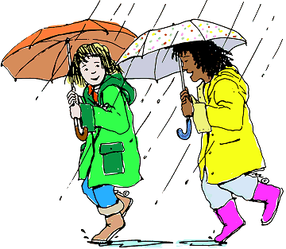At University Highlands we believe it is healthy for kids to get outside throughout the day for fresh air and exercise. Living on the West Coast we know that our climate contains a consistent amount of rainfall especially throughout the winter months. It makes sense that we are well prepared to be outside in the rain. Given that students will be outside for recess and lunch even when it’s raining it is important to send your child to school well prepared.

**Being prepared for the weather**

We know that if kids are well prepared to be outside in the rain they actually enjoy it. As long as they stay dry and warm there is a great deal of fun to be had in all kinds of weather. To be prepared to be outside in the rain it is important for your child to have:

* A rain coat or water resistant covering
* Rubber boots so they can enjoy the puddles
* Rain pants they can quickly slip over their clothes (much like they would snow pants)
* An umbrella
* A rain hat or coat with a hood
* A change of clothes just in case. (pants, socks, underwear, t-shirt) Smile



**Rainy Weather FAQ**

# I am concerned that my child will get sick being out in the rain.

It is not cold that makes us sick but rather viruses. “People get sick more often in the winter because they are exposed to each other more in the winter than in the summer. When it is cold outside people tend to stay inside and are more likely to spread germs to one another” (from "[*Does Cold Weather Cause the Cold or Flu*](http://coldflu.about.com/od/cold/f/coldandweather.htm)*?”*). Turns out that getting outdoors is more likely to protect our kids from illnesses than keeping them indoors.

# My child has been sick but is now returning to school. Can he stay inside today?

We are quite reluctant to allow this for a couple of reasons. First, if your child is still not quite better it would be best to stay at home until s/he is 100% ready to function fully at school. If your child is too sick to go outsides/ he is also probably too sick to get through the day’s work successfully. Secondly, we have limited supervision inside. We can make exceptions based on special circumstances. Please talk to your child’s teacher or the principal if this is the case.

# Why don’t you keep them in – they would be far more comfortable – it doesn’t seem fair!!

The habits we set up with our kids as they grow up last into adulthood. Rather than feeling that they need to stay indoors we want to encourage them to find ways to enjoy the rain. Students engage in imaginative play in any kind of weather. Rainy days inspire the construction of canals, dams, and islands. Puddle jumping is also a favourite activity! Fresh air and exercise also aid afternoon concentration.

# Are the children ever allowed to stay inside due to the weather?

We occasionally have weather conditions that are unreasonable to expect students to stay outside. These days include hard, driving rain or snow with extreme cold or wind. In these situations we intend to declare it an inside day however we don’t expect to have more than 2 or 3 of these a year.